Cameo Enterprise Architecture
Step 1: download trial version.

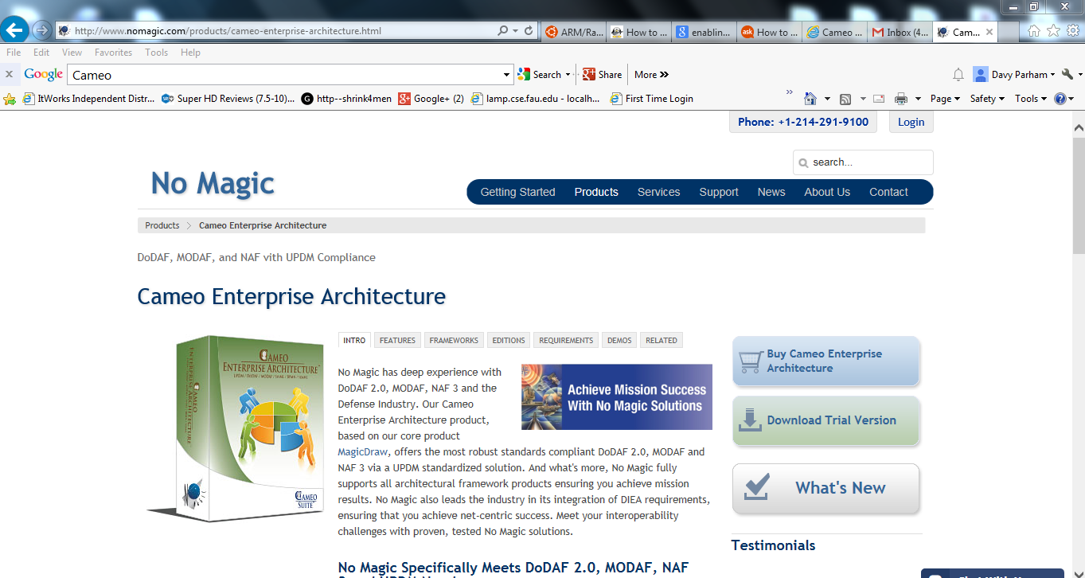

Step 2: Register account
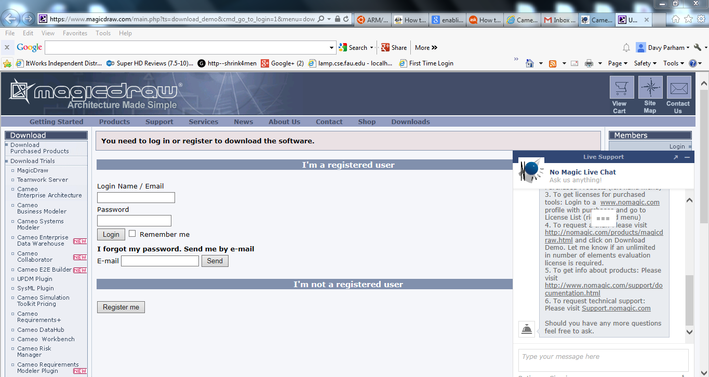
Step 3: select correct version “18.0 LTR”
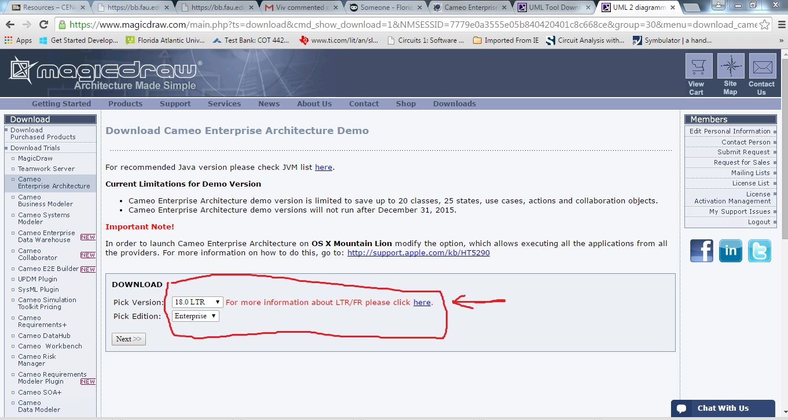

Step 4 Unzip folder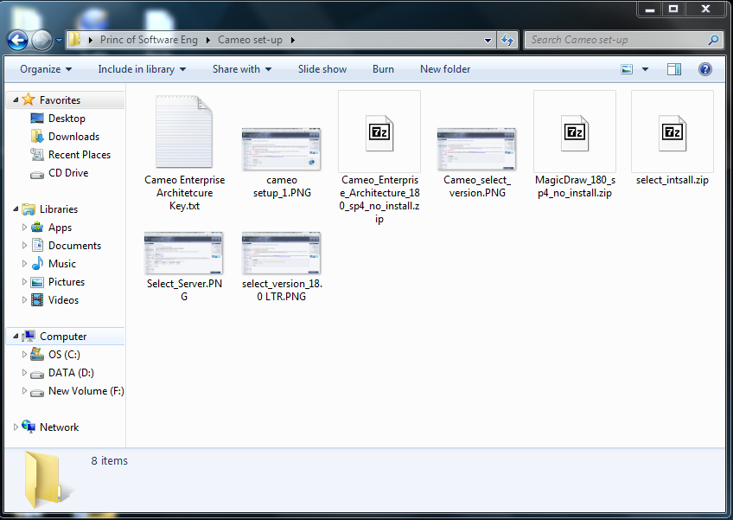

Follow steps 5 – 6 if installing manually. (only if you didn’t get the install file) otherwise skip to step 7
Step 5: open “bin” folder
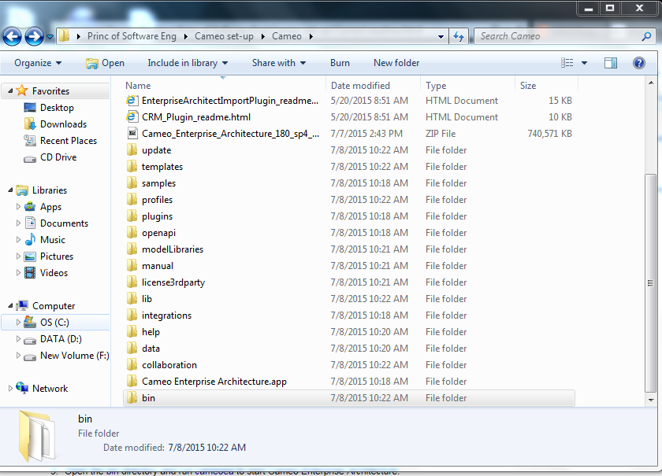

Step 6: run “cameoea.exe”
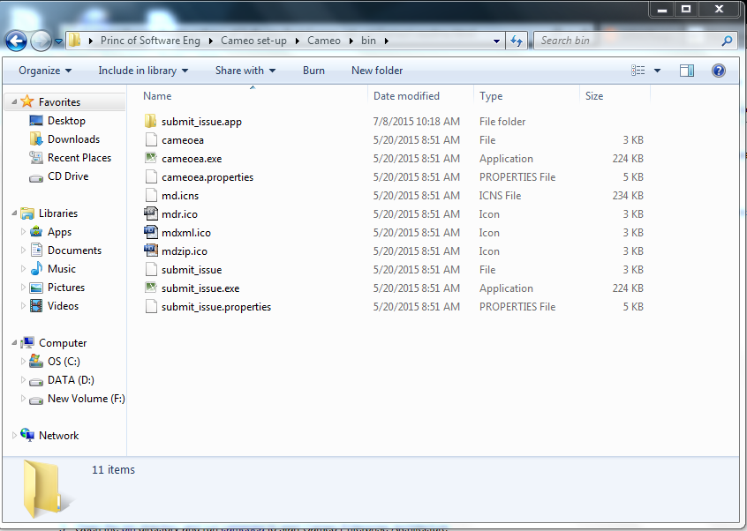

Step 7: Agree
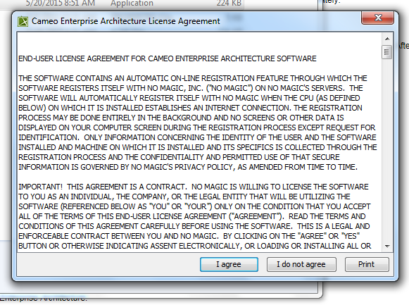

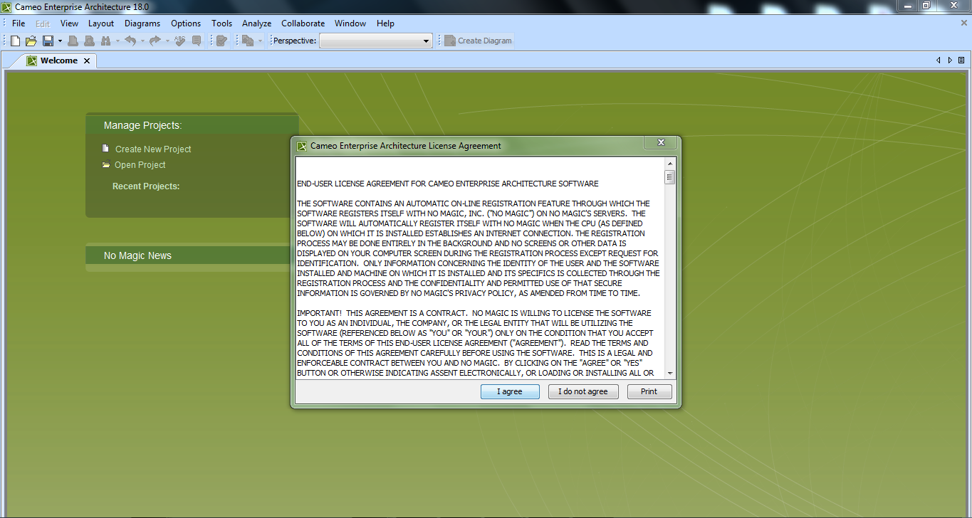
Step 8: Select License key Files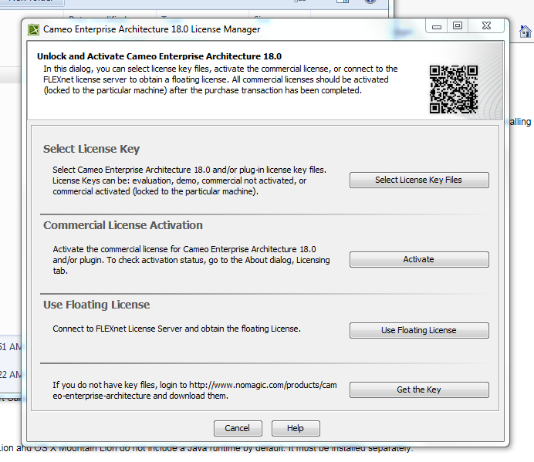

Step 9: Point to where you downloaded and saved the key from Blackboard
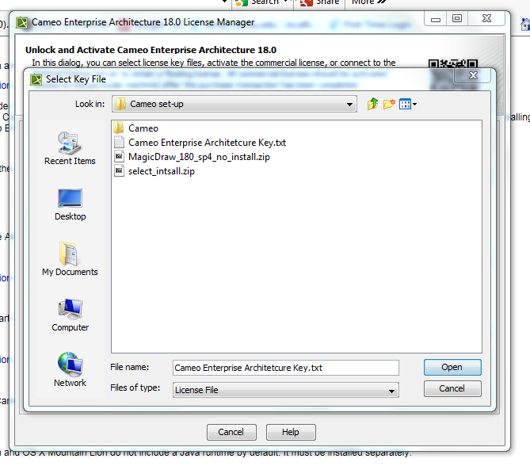

Step 10: Select SYSML then continue
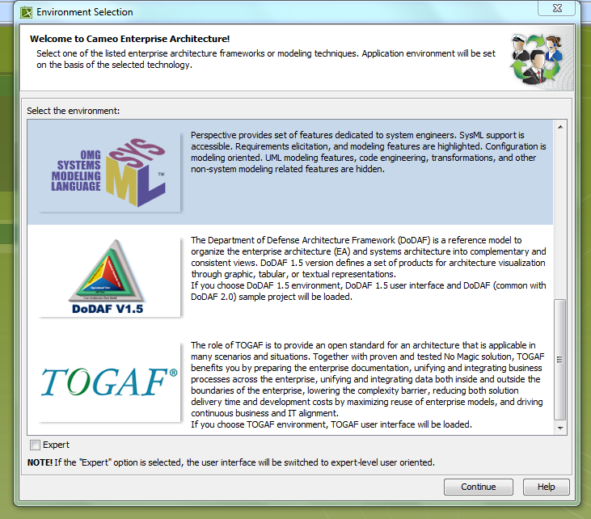

Continue to follow prompts from Cameo installation. That is all.
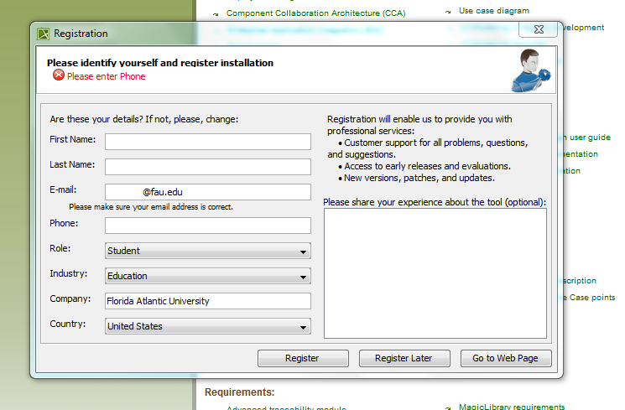
It will ask for your information and you will be sent a link to the email address you provided during the installation.
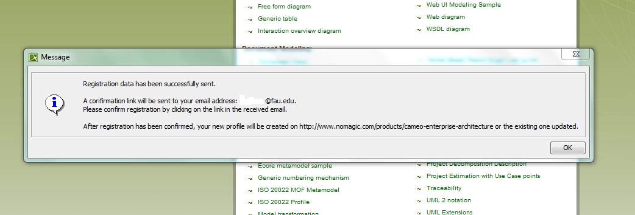

Open email and it will send you to a page
